1. 介绍和动机

As the Internet of Things products penetrate into our lives day by day, we are all gradually bound by it invisibly. And before we get completely tied down, we need to examine the individual possibilities people face with the Internet of Things. And replacing damaged equipment is an essential link when people use IoT products. Research shows that gender is the decisive factor for maintenance items, especially women are less involved in the maintenance of electronic products. We can start by studying the impact of gender on it in some related fields. And understand the details that need to be paid attention to when making the questionnaire。

图片：

xxxxxxxxxxxxxxxxxxxxxxxxxxxxxxxxxxxxxxxxxxxxxxxxxxxxxxxxxxxxxxxxxxxxxxxxxxxx

### 领域挑战

1. How to collect and analyze the experience and needs of citizens of different genders, social classes, age groups and geographical regions in using and maintaining IoT devices.

2. How to assess the impact of repair ability of IoT devices on equity, inclusion and sustainability in the digital economy.

3. How to design and implement IoT devices that are more aligned with citizens' legal rights, long-term cyber security, environmental sustainability, and community-serviceable networks.

4. How to improve the acceptance and innovation of wearable IoT devices among citizens of different genders.

These challenges require interdisciplinary collaboration, combining theories and methods from fields such as human-computer interaction, design, law, ethics, and digital humanities.

### 1.2：调查范围

The topics of my literature review include the impact of gender differences on some aspects of lot-related fields, and the details that should be paid attention to when conducting surveys about gender. At the same time, the topic also includes research on some defects of lot, and discusses the issue of lot numerical inequality. Even the topic included the introduction of the new concept "negotiated endurance" and the safety issue of the lot.

### 1.3：搜索方法

My approach uses a systematic search of existing literature in the fields of IoT, ethics, and digital humanities, and I focus on key words such as: "Internet of Things", "gender", "digital maintenance", "Ethics", "Consumer Perceptions and Attitudes", . I also included the following resources for my search method:

NUsearch

Google Scholar

Baidu Scholar

Connected Papers

Semantic Scholar

First, I sent an email to my supervisor to ask for some papers on related topics to read, then I used keywords to search for several papers in Google Scholar, and finally I focused on using CONNECTED PAPERS to search for other related papers[Figure 1] , and then select papers that are more complex with my research topic.

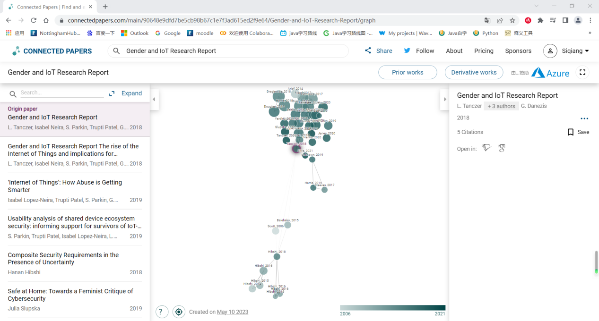Figure1[connected papers]

### 1.4文献分类和组织

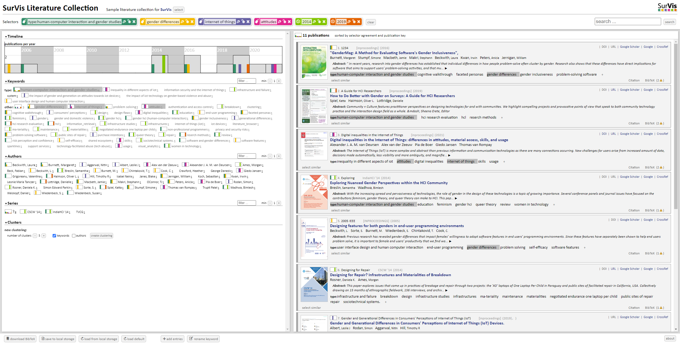I use SurVis for classification. The basis of my classification is based on keywords, such as human-computer interaction and gender studies, gender differences, etc. and I uploaded it to my GitHub.

## 论文摘要

<Designing features for both genders in end-user programming environments>

The main contribution of this paper is to explore the role of gender differences in influencing user acceptance and use of software features in end-user programming environments, and to propose theory-based approaches to design features that are more gender-appropriate.

The paper followed a four-step survey approach:

(1) Use other domains to hypothesize possible gender issues in research and why; [Figure 2]

(2) Use experimental methods to verify;

(3) Qualitative empirical research using the results of the first two steps to improve problem-solving;

(4) Use quantitative empirical methods to evaluate the effectiveness of these methods.

Several aspects of related work in this paper:

(1) Focus on the causes and solutions of underrepresentation of women in computing;

(2) Summarize relevant hypotheses, such as sex difference theory

(3) Focus on how to embed functions in the end-user programming environment that help users prevent and detect errors;

(4) We explore strategies for rewarding users by prompting them with explanations of software functionality and motivating them to try and learn. The paper uses questionnaire data and diary data to assess the impact of gender differences on the use of software features. This paper uses experimental and qualitative analysis to assess the impact of gender differences on the use of software features.

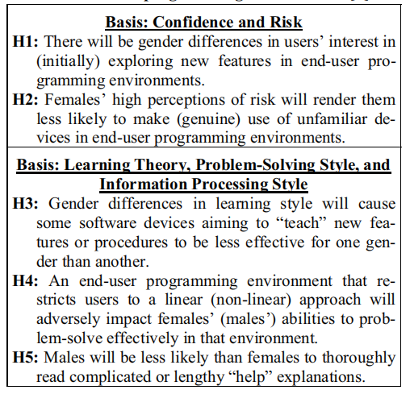

Figure2[Theory-based hypotheses about gender differences]

**<Designing for repair infrastructures and materialities of breakdown>**

This paper proposes a new concept, negotiated durability, to describe the physical realities and practices of restoration and how they are influenced by physical, infrastructural, gender, political and socioeconomic factors. Using qualitative and ethnographic methods, the paper analyzes the phenomena of damage and restoration across two projects, based on 15 months of fieldwork, 156 interviews and archival research.

The main references are related work in the following fields:

1. Ethnographic research on maintenance work, sustainable interaction design

2. Homebrew and hacker culture, and the politics of sociotechnical systems

The paper uses a variety of data sources, including field notes, interview records, archival materials, maintenance logs, and repair parts lists. Data are from Paraguay and California, USA, and cover a variety of participants.

Using a qualitative approach, the paper extracts four themes from the data and supports them with specific examples and quotes. The authors also discuss the implications of their findings for design theory and practice, offering some design suggestions and challenges

**<Exploring Nuanced Gender Perspectives within the HCI Community>**

The main part of the paper reviews and summarizes key developments in Gender Human-Computer Interaction (Gender HCI) over the past five years, in particular how to move beyond differences in technology use between men and women to focus on radical, intersectional, and reflective design approaches, To promote inclusiveness and responsibility. The research method of the thesis is a literature review, which mainly analyzes gender-human-computer interaction-related papers published in journals and conferences such as CHI, Interacting with Computers, Science, Technology & Human Values in recent years, as well as some doctoral theses and workshop reports.

Core related work of the paper:

1. Gender theory, such as feminism, queer theory, postcolonial theory, etc.

2. Historical Development of Gender-Human-Computer Interaction

3. Main topics of gendered human-computer interaction

The data characteristics of the papers are based on secondary data, that is, published papers on gender-based human-computer interaction.

The evaluation type of the paper is theoretical evaluation, that is, to analyze and comment on the existing gender-human-computer interaction research according to gender theory and design principles, and to propose future research directions and suggestions.

**<Gender and IoT Research Report>**

The main contribution of this paper is to analyze the potential risks and impacts of Internet of Things (IoT) technology in domestic violence and sexual assault, and to put forward some targeted recommendations. The dissertation adopts an interdisciplinary research method, combining the perspectives of social science, cybersecurity and gender studies, and collects and analyzes data and information on technology abuse and the Internet of Things through literature review, case analysis, interviews and surveys.

The core related work of this paper is:

1. Existing literature on technology-facilitated abuse

2. New risks and challenges brought by IoT technology

3. The need for collaboration and capacity building among different stakeholders

The paper uses multiple types of data, both quantitative and qualitative, to support its analysis and arguments. For example, it uses statistics provided by the ONS, but also interviews and survey data from various stakeholders. The paper uses the method of critical evaluation to evaluate the role of Internet of Things technology in domestic violence and sexual assault, and puts forward some targeted suggestions.

**<Gender HCI What About the Software>**

This paper introduces a research field called Gender HCI, which aims to explore the relationship between software and gender differences. The dissertation studies the differences in feature usage, self-efficacy, and error repairing among users of different genders through a variety of evaluation methods, including qualitative and quantitative experimental methods and thought-reporting methods. The findings identified propensities, significance, manifestations, causes, and effects of sex differences [Figure 3]. In addition, the dissertation explores research on gender differences in computer confidence, technology adoption models, computer games, and computer science career choices, as well as the application of self-efficacy theory and problem-solving strategies to education. The solutions proposed in this thesis are proposed based on the previous two steps of empirical research and qualitative empirical work, and the effectiveness of the solutions is also evaluated by quantitative empirical methods.

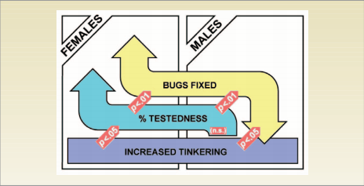Figure3[Gender affects debugging efficiency]

**<GenderMag A Method for Evaluating Software's Gender Inclusiveness>**

This paper presents a method called GenderMag for evaluating the gender inclusivity of problem-solving software, which encapsulates five aspects related to gender differences into a set of personas with different gender and aspect values, and embeds to a cognitive walk-based process. Through three empirical studies, the approach can help practitioners identify and address real issues of gender inclusion. The paper describes in detail the various components of the GenderMag methodology and how it can be used to evaluate software. The paper also reviews research related to gender differences and the application of analytical assessment and personas to software design and evaluation. Three empirical studies used different types and stages of problem-solving software and collected a variety of data. This paper is a qualitative evaluation that explores the issue of gender inclusivity in software through interviews, observations, and document analysis, and proposes an evaluation method based on cognitive walkthroughs.

**<How to do better with gender on surveys a guide for HCI researchers>**

The main contribution of this paper is to provide some best practices to help HCI researchers better investigate and report gender. The paper describes some common gender survey problems and pitfalls [Figure4] and gives specific recommendations and examples [Figure5], including making gender questions optional, using checkboxes, providing multiple choices and opportunities for self-description, Avoid using other or similar words etc. This paper takes a guided approach, offering these recommendations by introducing relevant concepts from intersectionality theory and user representation work, as well as the authors' own experiences and reflections. The paper mainly refers to intersectionality theory, user representation work and identity-related HCI work. The data come mainly from the author's experience and reflection, as well as the survey and analysis of historical literature of CHI conferences. The paper uses a guided assessment to assess the performance and room for improvement of the authors themselves and the CHI community in addressing gender issues. This type of assessment can help HCI researchers to consider and present the gender complexities of their subjects and themselves more sensitively and responsibly.

Figure4[Recommended form]

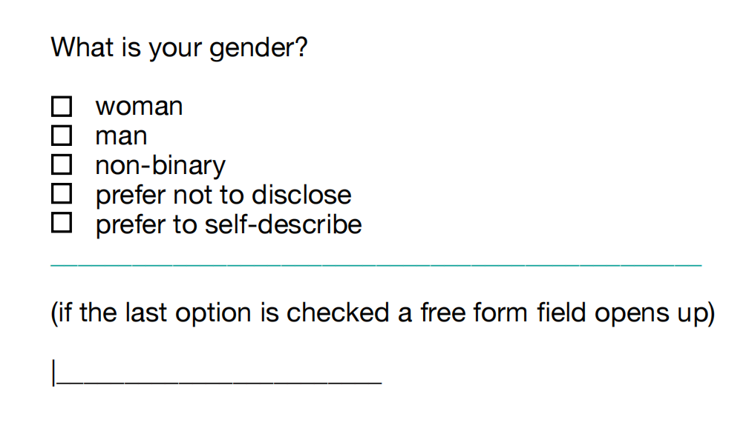

Figure5[Only default settings]

**<Never Ending Story Authentication and Access Control Design Flaws in Shared IoT Devices>**

This paper examines authentication and access control design flaws in Internet of Things (IoT) devices [Figure 6], and explores their impact on user privacy and security. Using methods from laboratory testing and network analysis, the paper proposes an attack method that enables persistent access to device functionality after credential modification or revocation. The paper evaluates the vulnerability of 19 popular security cameras and doorbells to this attack and finds 16 devices to be flawed [Figure 7]. The paper also discusses the reasons for these findings and possible countermeasures. The data source for this paper is 19 different brands and models of IoT cameras and doorbells, which are popular and common in 2019. The paper mainly uses quantitative evaluation methods, but also cites some related work and cases to illustrate the background and motivation of the research. The paper highlights the importance of improving the security and transparency of IoT device authentication and access control schemes.

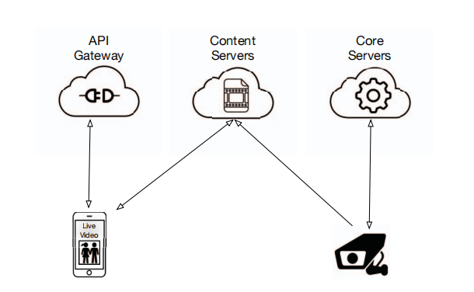

Figure6[access control flaws into designs and implementations.]

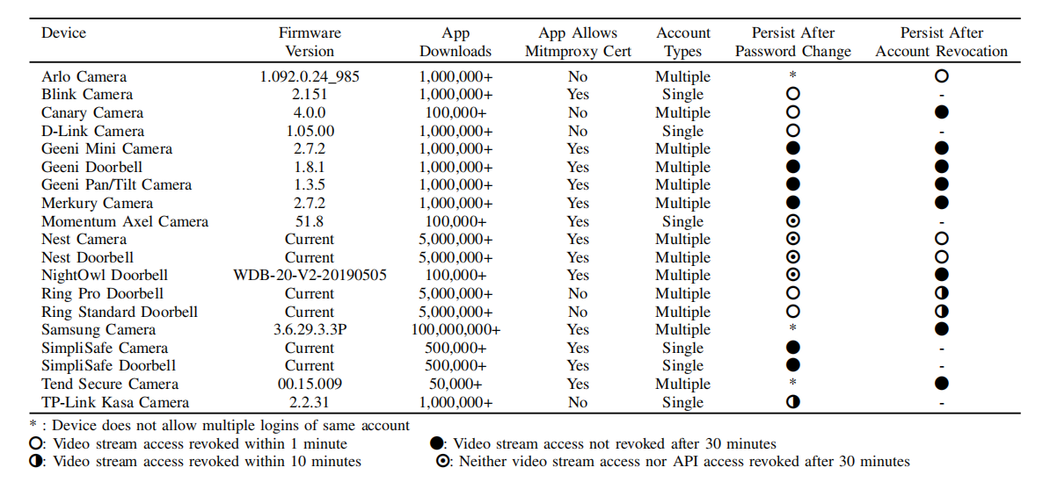

Figure7[The results after experimenting with 19 devices]

**<Gender and Generational Differences in Consumers’ Perceptions of Internet of Things (IoT) Devices >**

This paper examines the impact of gender and generation on consumer familiarity with Internet of Things (IoT) devices, security concerns, and purchase intentions, analyzing data from a survey of 463 undergraduate business students at a large North American university . Citing research in the fields of information systems, marketing, psychology, and education, the paper used regression analysis to test six hypotheses. The study used a six-point Likert scale to measure consumer attitudes towards IoT devices, while collecting the gender and age range of the respondents. The study found that gender and intergenerational factors have a significant impact on consumer attitudes, and there is also an interaction between gender and intergenerational factors. The paper reports the regression model's coefficients, standard errors, significance levels, and model fit statistics. The research contributes to the literature in the fields of information systems and marketing by exploring the IoT value/trust paradox and how it varies across populations.

**<Digital inequalities in the Internet of Things: differences in attitudes, material access, skills, and usage>**

The paper explores digital inequalities in the Internet of Things (IoT) and examines differences in health, family and security-related IoT among the Dutch population across four dimensions: attitudes, material acquisition, skills and use. Using a quantitative approach, a data set representative of the Dutch adult population was collected using an online survey, and the data were statistically analyzed using linear regression [Figure 8] and path analysis to explore resource, location, and individual factors that influence these differences. The paper draws on relevant literature on IoT and digital inequality, and identifies gaps in existing research. The data are highly reliable and representative and can reflect the situation of the Dutch adult population in terms of IoT. Methods such as descriptive statistics, linear regression and path analysis were used to evaluate the data and test the hypotheses proposed by the authors. This paper fills the gap in IoT research that ignores user characteristics and social influence, providing valuable insights for understanding and bridging the digital divide of IoT.

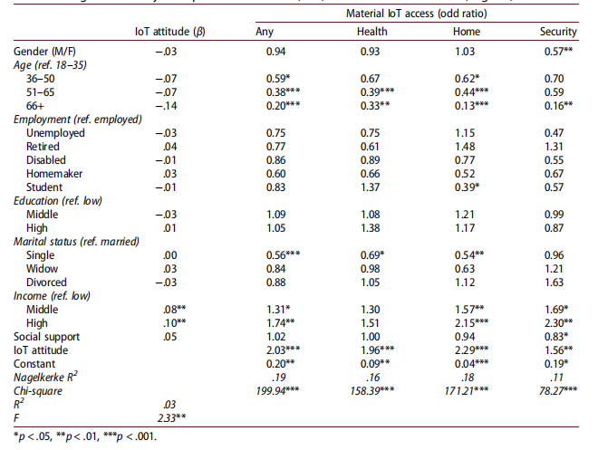

Figure8[Regression analysis to predict]

## References:

[1]Beckwith, L., Sorte, S., Burnett, M., Wiedenbeck, S., Chintakovid, T., & Cook, C. (2005, September). Designing features for both genders in end-user programming environments. In 2005 IEEE Symposium on Visual Languages and Human-Centric Computing (VL/HCC'05) (pp. 153-160). IEEE.

[2]Rosner, D. K., & Ames, M. (2014, February). Designing for repair Infrastructures and materialities of breakdown. In Proceedings of the 17th ACM conference on Computer supported cooperative work & social computing (pp. 319-331).

1. Breslin, S., & Wadhwa, B. (2014, December). Exploring nuanced gender perspectives within the HCI community. In Proceedings of the india hci 2014 conference on human computer interaction (pp. 45-54).

[4]Tanczer, L., Lopez-Neira, I., Parkin, S., Patel, T., & Danezis, G. (2018). Gender and IoT research report: The rise of the Internet of Things and implications for technology-facilitated abuse.

[5]Beckwith, L., Burnett, M., Grigoreanu, V., & Wiedenbeck, S. (2006). Gender HCI: What about the software?. Computer, 39(11), 97-101.

[6]Burnett, M., Stumpf, S., Macbeth, J., Makri, S., Beckwith, L., Kwan, I., ... & Jernigan, W. (2016). GenderMag: A method for evaluating software's gender inclusiveness. Interacting with Computers, 28(6), 760-787.

[7]Spiel, K., Haimson, O. L., & Lottridge, D. (2019). How to do better with gender on surveys: a guide for HCI researchers. Interactions, 26(4), 62-65.

[8]Janes, B., Crawford, H., & OConnor, T. J. (2020, May). Never ending story: authentication and access control design flaws in shared IoT devices. In 2020 IEEE Security and Privacy Workshops (SPW) (pp. 104-109). IEEE.

[9]Albert, L. J., Rodan, S., Aggarwal, N., & Hill, T. R. (2019). Gender and Generational Differences in Consumers' Perceptions of Internet of Things (IoT) Devices. E-Journal of Social & Behavioural Research in Business, 10(3).

[10]van Deursen, A. J., van der Zeeuw, A., de Boer, P., Jansen, G., & van Rompay, T. (2021). Digital inequalities in the Internet of Things: differences in attitudes, material access, skills, and usage. Information, Communication & Society, 24(2), 258-276.